**Task 2**

**Statistical Analysis**

**Dataset “data_for_analysis”** **(except lipids 5)**

Dong Wenyu

Data Analysis

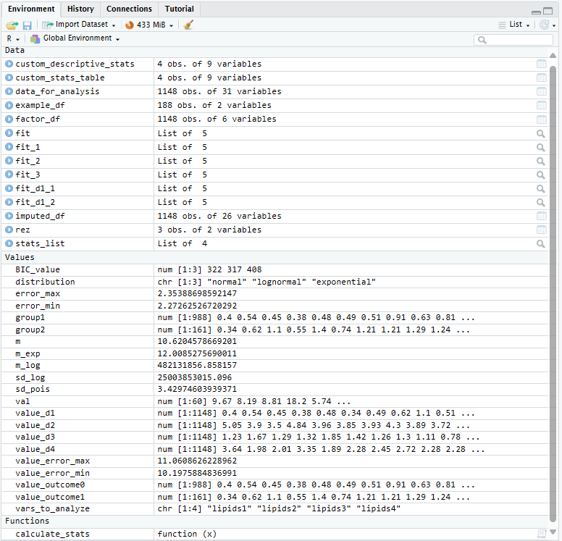

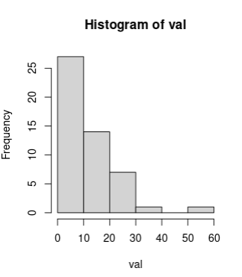

exponential distribution

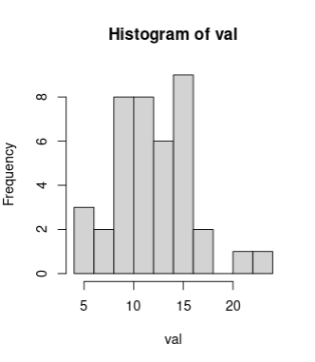

normal distribution

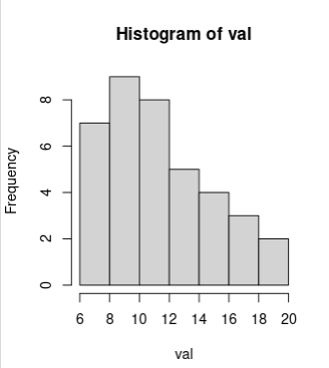

Poisson distribution

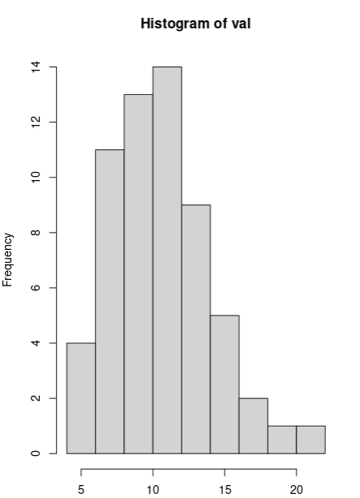

lognormal distribution

